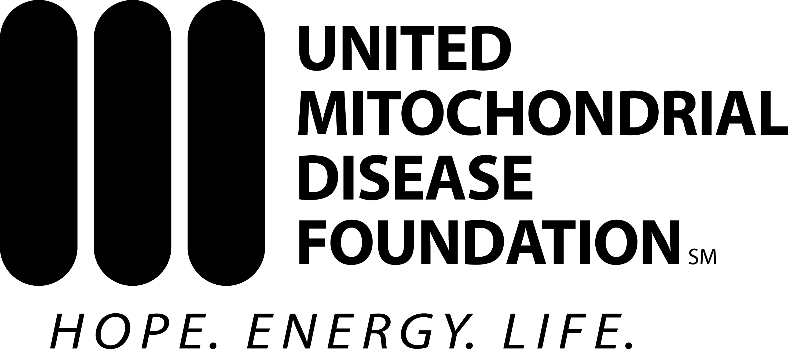

CONTACT: TYPE IN YOUR NAME
TYPE IN YOUR PHONE NUMBER

FOR IMMEDIATE RELEASE
INSERT DATE

INSERT HEADLINE OF YOUR RELEASE

(INSERT YOUR TOWN, STATE INITIALS)

(WRITE YOUR RELEASE HERE)

(THESE TWO PARAGRAPHS ARE BOILERPLATE LANGUAGE THAT MUST BE INCLUDED IN ALL NEWS RELEASES)

About Mitochondrial Disease
Every 30 minutes, a child is born who will develop a mitochondrial disease by age 10. Mitochondrial diseases result from the failure of the mitochondria, which is a located in the cells of our bodies. Mitochondria are responsible for creating more than 90% of the energy needed to sustain life and support growth. When mitochondria fail, less energy is produced causing cell injury or cell death. On a larger scale, organ systems begin to fail. The disease is often debilitating. Children with mitochondrial disease may not see their teenage years.

About the United Mitochondrial Disease Foundation
Founded in 1996, the UMDF works to promote research and education for the diagnosis, treatment and cure of mitochondrial diseases and to provide support for affected individuals and families. Since its inception, the UMDF has funded nearly $6 million in research, making it the leading non-governmental contributor of grants focused solely on mitochondrial disease. The UMDF, based in Pittsburgh, is a national organization, represented by 14 chapters around the United States and thousands of members who participate in groups and as ambassadors.

